Performance Ranking – CSR Group Sub Surface Canada

= ranking

Veal Derkach
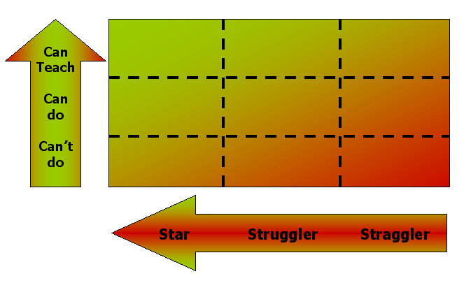

Hogan

Management Action Key

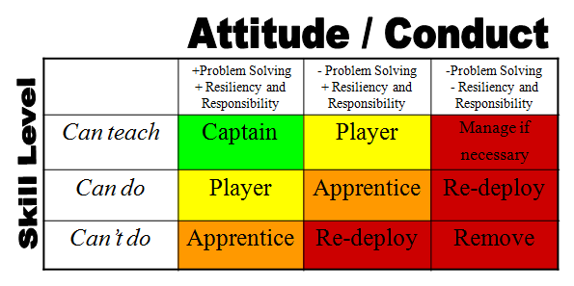
Captain = internal teacher and guide for others
Player = front line performer
Apprentice = under supervision
Manage if necessary = careful deployment, constant supervision, planned redeployment or removal
Re-deploy = not suitable for current role however useful to company
Remove = not suitable for role or company

